**AWS CLOUDFRONT**

[Anytime in the exam you see CDN, think CloudFront]

* CloudFront is a Content Delivery Network (CDN)
* It improves the read performance, by caching the content at different edge locations.
* As the content is cached all around the world, it improves user experience all round the world.
* CloudFront is made of 216 points of presence globally (edge locations) which corresponds to the AWS edge locations around the world.
* DDoS protection, integration with shield, AWS Web Application Firewall
* DDoS is a type sort of attack where all your servers around the world are getting attacked at the same time.
* Say we had created an S3 bucket and a website on our S3 bucket in Australia, but we had a user in maybe America, then what the user will do is that it will request the content from an American edge location using CloudFront, and CloudFront will be able to fetch the contents from Australia

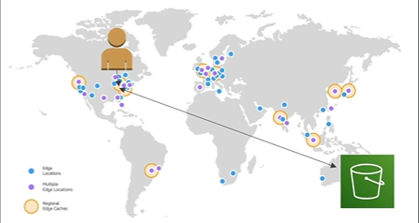

**CloudFront – Origins**

* **S3 Bucket**
* For distributing files and caching them at the edge locations
* Enhanced security with CloudFront *Origin Access Control* (OAC)
* OAC is replacing OAI (origin access identity)
* CF can be used as an ingress (to upload files to S3)
* **Custom Origin (HTTP)** [can have CloudFront as well instead in front of any custom origin HTTP backend]
* Application Load Balancer
* EC2 Instance
* S3 Website (must first enable the bucket as a static S3 website)
* Any HTTP backend you want

If a user accesses a content, CloudFront will check for it in all the edge locations if its cached, if not, it will go to the CloudFront origin and fetch the content and will keep it cached until TTL (Time to live), probably a day.

If a content is loaded, say from a S3 bucket, and you refresh the page again, the refreshed content will be from the CloudFront instead of the S3 bucket.

